Lab – Configuring and Verifying Extended ACLs

1. Topology

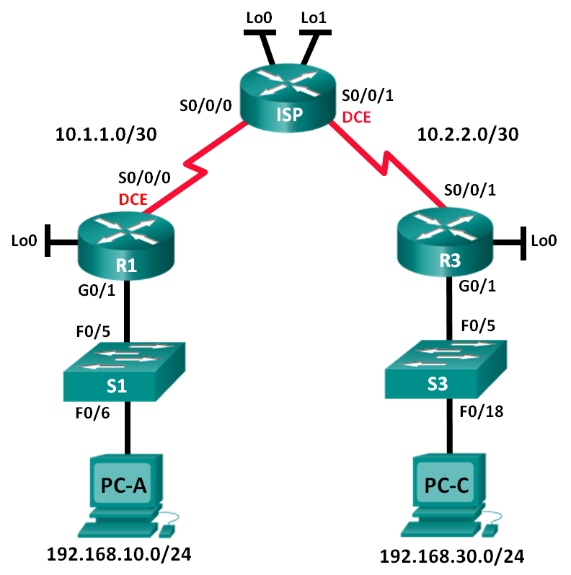

1. Addressing Table

|  |  |  |  |  |
| --- | --- | --- | --- | --- |
| Device | Interface | IP Address | Subnet Mask | Default Gateway |
| R1 | G0/1 | 192.168.10.1 | 255.255.255.0 | N/A |
|  | Lo0 | 192.168.20.1 | 255.255.255.0 | N/A |
|  | S0/0/0 (DCE) | 10.1.1.1 | 255.255.255.252 | N/A |
| ISP | S0/0/0 | 10.1.1.2 | 255.255.255.252 | N/A |
|  | S0/0/1 (DCE) | 10.2.2.2 | 255.255.255.252 | N/A |
|  | Lo0 | 209.165.200.225 | 255.255.255.224 | N/A |
|  | Lo1 | 209.165.201.1 | 255.255.255.224 | N/A |
| R3 | G0/1 | 192.168.30.1 | 255.255.255.0 | N/A |
|  | Lo0 | 192.168.40.1 | 255.255.255.0 | N/A |
|  | S0/0/1 | 10.2.2.1 | 255.255.255.252 | N/A |
| S1 | VLAN 1 | 192.168.10.11 | 255.255.255.0 | 192.168.10.1 |
| S3 | VLAN 1 | 192.168.30.11 | 255.255.255.0 | 192.168.30.1 |
| PC-A | NIC | 192.168.10.3 | 255.255.255.0 | 192.168.10.1 |
| PC-C | NIC | 192.168.30.3 | 255.255.255.0 | 192.168.30.1 |

1. Objectives

Part 1: Set Up the Topology and Initialize Devices

Part 2: Configure Devices and Verify Connectivity

* Configure basic settings on PCs, routers, and switches.
* Configure OSPF routing on R1, ISP, and R3.

Part 3: Configure and Verify Extended Numbered and Named ACLs

* Configure, apply, and verify a numbered extended ACL.
* Configure, apply, and verify a named extended ACL.

Part 4: Modify and Verify Extended ACLs

1. Background / Scenario

Extended access control lists (ACLs) are extremely powerful. They offer a much greater degree of control than standard ACLs as to the types of traffic that can be filtered, as well as where the traffic originated and where it is going.

In this lab, you will set up filtering rules for two offices represented by R1 and R3. Management has established some access policies between the LANs located at R1 and R3, which you must implement. The ISP router between R1 and R3 does not have any ACLs placed on it. You would not be allowed any administrative access to an ISP router as you can only control and manage your own equipment.

1. Required Resources

* 3 Routers (Cisco 1941)
* 2 Switches (Cisco 2960)
* 2 PCs
* Ethernet and serial cables as shown in the topology

1. Set Up the Topology and Initialize Devices

In Part 1, you will set up the network topology and clear any configurations if necessary.

* 1. Cable the network as shown in the topology.
  2. Initialize and reload the routers and switches.

1. Configure Devices and Verify Connectivity

In Part 2, you will configure basic settings on the routers, switches, and PCs. Refer to the Topology and Addressing Table for device names and address information.

* 1. Configure IP addresses on PC-A and PC-C.
  2. Configure basic settings on R1.
     1. Disable DNS lookup.
     2. Configure the device name as shown in the topology.
     3. Create a loopback interface on R1.
     4. Configure interface IP addresses as shown in the Topology and Addressing Table.
     5. Configure a privileged EXEC mode password of **class**.
     6. Assign a clock rate of **128000** to the S0/0/0 interface.
     7. Assign **cisco** as the console and vty password and enable Telnet access. Configure **logging synchronous** for both the console and vty lines.
     8. Enable web access on R1 to simulate a web server with local authentication for user **admin**.

R1(config)# **ip http server**

R1(config)# **ip http authentication local**

R1(config)# **username admin privilege 15 secret class**

* 1. Configure basic settings on ISP.
     1. Configure the device name as shown in the topology.
     2. Create the loopback interfaces on ISP.
     3. Configure interface IP addresses as shown in the Topology and Addressing Table.
     4. Disable DNS lookup.
     5. Assign **class** as the privileged EXEC mode password.
     6. Assign a clock rate of **128000** to the S0/0/1 interface.
     7. Assign **cisco** as the console and vty password and enable Telnet access. Configure **logging synchronous** for both console and vty lines.
     8. Enable web access on the ISP. Use the same parameters as in Step 2h.
  2. Configure basic settings on R3.
     1. Configure the device name as shown in the topology.
     2. Create a loopback interface on R3.
     3. Configure interface IP addresses as shown in the Topology and Addressing Table.
     4. Disable DNS lookup.
     5. Assign **class** as the privileged EXEC mode password.
     6. Assign **cisco** as the console password and configure **logging synchronous** on the console line.
     7. Enable SSH on R3.

R3(config)# **ip domain-name cisco.com**

R3(config)# **crypto key generate rsa modulus 1024**

R3(config)# **line vty 0 4**

R3(config-line)# **login local**

R3(config-line)# **transport input ssh**

* + 1. Enable web access on R3. Use the same parameters as in Step 2h.
  1. (Optional) Configure basic settings on S1 and S3.
     1. Configure the hostnames as shown in the topology.
     2. Configure the management interface IP addresses as shown in the Topology and Addressing Table.
     3. Disable DNS lookup.
     4. Configure a privileged EXEC mode password of **class**.
     5. Configure a default gateway address.
  2. Configure OSPF routing on R1, ISP, and R3.
     1. Assign 1 as the OSPF process ID and advertise all networks on R1, ISP, and R3. The OSPF configuration for R1 is included for reference.

R1(config)# **router ospf 1**

R1(config-router)# **network 192.168.10.0 0.0.0.255 area 0**

R1(config-router)# **network 192.168.20.0 0.0.0.255 area 0**

R1(config-router)# **network 10.1.1.0 0.0.0.3 area 0**

* + 1. After configuring OSPF on R1, ISP, and R3, verify that all routers have complete routing tables listing all networks. Troubleshoot if this is not the case.
  1. Verify connectivity between devices.

**Note**: It is very important to verify connectivity **before** you configure and apply ACLs! Ensure that your network is properly functioning before you start to filter out traffic.

* + 1. From PC-A, ping PC-C and the loopback and serial interfaces on R3.

Were your pings successful? ________

* + 1. From R1, ping PC-C and the loopback and serial interface on R3.

Were your pings successful? ________

* + 1. From PC-C, ping PC-A and the loopback and serial interface on R1.

Were your pings successful? ________

* + 1. From R3, ping PC-A and the loopback and serial interface on R1.

Were your pings successful? ________

* + 1. From PC-A, ping the loopback interfaces on the ISP router.

Were your pings successful? ________

* + 1. From PC-C, ping the loopback interfaces on the ISP router.

Were your pings successful? ________

* + 1. Open a web browser on PC-A and go to <http://209.165.200.225> on ISP. You will be prompted for a username and password. Use **admin** for the username and **class** for the password. If you are prompted to accept a signature, accept it. The router will load the Cisco Configuration Professional (CCP) Express in a separate window. You may be prompted for a username and password. Use **admin** for the username and **class** for the password.
    2. Open a web browser on PC-C and go to <http://10.1.1.1> on R1. You will be prompted for a username and password. Use **admin** for username and **class** for the password. If you are prompted to accept a signature, accept it. The router will load CCP Express in a separate window. You may be prompted for a username and password. Use **admin** for the username and **class** for the password.

1. Configure and Verify Extended Numbered and Named ACLs

Extended ACLs can filter traffic in many different ways. Extended ACLs can filter on source IP addresses, source ports, destination IP addresses, destination ports, as well as various protocols and services.

Security policies are as follows:

1. Allow web traffic originating from the 192.168.10.0/24 network to go to any network.
2. Allow an SSH connection to the R3 serial interface from PC-A.
3. Allow users on 192.168.10.0/24 network access to 192.168.20.0/24 network.
4. Allow web traffic originating from the 192.168.30.0/24 network to access R1 via the web interface and the 209.165.200.224/27 network on ISP. The 192.168.30.0/24 network should NOT be allowed to access any other network via the web.

In looking at the security policies listed above, you will need at least two ACLs to fulfill the security policies. A best practice is to place extended ACLs as close to the source as possible. We will follow this practice for these policies.

* 1. Configure a numbered extended ACL on R1 for security policy numbers 1 and 2.

You will use a numbered extended ACL on R1. What are the ranges for extended ACLs?

_______________________________________________________________________________________

* + 1. Configure the ACL on R1. Use 100 for the ACL number.

R1(config)# **access-list 100 remark Allow Web & SSH Access**

R1(config)# **access-list 100 permit tcp host 192.168.10.3 host 10.2.2.1 eq 22**

R1(config)# **access-list 100 permit tcp any any eq 80**

What does the 80 signify in the command output listed above?

____________________________________________________________________________________

To what interface should ACL 100 be applied?

____________________________________________________________________________________

____________________________________________________________________________________

In what direction should ACL 100 be applied?

____________________________________________________________________________________

____________________________________________________________________________________

* + 1. Apply ACL 100 to the S0/0/0 interface.

R1(config)# **interface s0/0/0**

R1(config-if)# **ip access-group 100 out**

* + 1. Verify ACL 100.
       1. Open up a web browser on PC-A, and access <http://209.165.200.225> (the ISP router). It should be successful; troubleshoot, if not.
       2. Establish an SSH connection from PC-A to R3 using 10.2.2.1 for the IP address. Log in with **admin** and **class** for your credentials. It should be successful; troubleshoot, if not.
       3. From privileged EXEC mode prompt on R1, issue the **show access-lists** command.

R1# **show access-lists**

Extended IP access list 100

10 permit tcp host 192.168.10.3 host 10.2.2.1 eq 22 (22 matches)

20 permit tcp any any eq www (111 matches)

* + - 1. From the PC-A command prompt, issue a ping to 10.2.2.1. Explain your results.

________________________________________________________________________________

________________________________________________________________________________

________________________________________________________________________________

* 1. Configure a named extended ACL on R3 for security policy number 3.
     1. Configure the policy on R3. Name the ACL WEB-POLICY.

R3(config)# **ip access-list extended WEB-POLICY**

R3(config-ext-nacl)# **permit tcp 192.168.30.0 0.0.0.255 host 10.1.1.1 eq 80**

R3(config-ext-nacl)# **permit tcp 192.168.30.0 0.0.0.255 209.165.200.224 0.0.0.31 eq 80**

* + 1. Apply ACL WEB-POLICY to the S0/0/1 interface.

R3(config-ext-nacl)# **interface S0/0/1**

R3(config-if)# **ip access-group WEB-POLICY out**

* + 1. Verify the ACL WEB-POLICY.
       1. From R3 privileged EXEC mode command prompt, issue the **show ip interface s0/0/1** command.

What, if any, is the name of the ACL? ______________________________________

In what direction is the ACL applied? _______________________________________

* + - 1. Open up a web browser on PC-C and access <http://209.165.200.225> (the ISP router). It should be successful; troubleshoot, if not.
      2. From PC-C, open a web session to <http://10.1.1.1> (R1). It should be successful; troubleshoot, if not.
      3. From PC-C, open a web session to <http://209.165.201.1> (ISP router). It should fail; troubleshoot, if not.
      4. From a PC-C command prompt, ping PC-A. What was your result and why?

________________________________________________________________________________

1. Modify and Verify Extended ACLs

Because of the ACLs applied on R1 and R3, no pings or any other kind of traffic is allowed between the LAN networks on R1 and R3. Management has decided that all traffic between the 192.168.10.0/24 and 192.168.30.0/24 networks should be allowed. You must modify both ACLs on R1 and R3.

* 1. Modify ACL 100 on R1.
     1. From R1 privileged EXEC mode, issue the **show access-lists** command.

How many lines are there in this access list? _____________________

* + 1. Enter global configuration mode and modify the ACL on R1.

R1(config)# **ip access-list extended 100**

R1(config-ext-nacl)# **30 permit ip 192.168.10.0 0.0.0.255 192.168.30.0 0.0.0.255**

R1(config-ext-nacl)# **end**

* + 1. Issue the **show access-lists** command.

Where did the new line that you just added appear in ACL 100?

____________________________________________________________________________________

* 1. Modify ACL WEB-POLICY on R3.
     1. From R3 privileged EXEC mode, issue the **show access-lists** command.

How many lines are there in this access list? ________________________

* + 1. Enter global configuration mode and modify the ACL on R3.

R3(config)# **ip access-list extended WEB-POLICY**

R3(config-ext-nacl)# **30 permit ip 192.168.30.0 0.0.0.255 192.168.10.0 0.0.0.255**

R3(config-ext-nacl)# **end**

* + 1. Issue the **show access-lists** command to verify that the new line was added at the end of the ACL.
  1. Verify modified ACLs.
     1. From PC-A, ping the IP address of PC-C. Were the pings successful? ______________
     2. From PC-C, ping the IP address of PC-A. Were the pings successful? ______________

Why did the ACLs work immediately for the pings after you changed them?

____________________________________________________________________________________

1. Reflection
   1. Why is careful planning and testing of ACLs required?

_______________________________________________________________________________________

_______________________________________________________________________________________

* 1. Which type of ACL is better: standard or extended?

_______________________________________________________________________________________

_______________________________________________________________________________________

_______________________________________________________________________________________

_______________________________________________________________________________________

* 1. Why are OSPF hello packets and routing updates not blocked by the implicit **deny any** access control entry (ACE) or ACL statement of the ACLs applied to R1 and R3?

_______________________________________________________________________________________

_______________________________________________________________________________________

_______________________________________________________________________________________

_______________________________________________________________________________________